Navigate to the class you want to operate on and open its private data control.

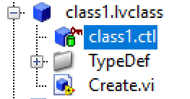

To open private control right click on it and select open.

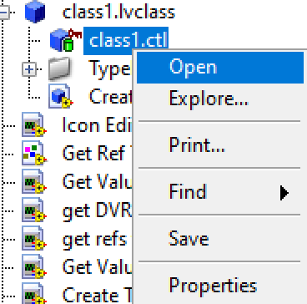

To create new DVR use “New Data Value Reference” function from memory control palette.

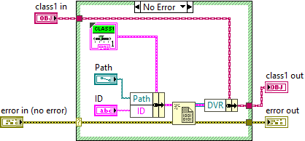

Usually class by reference has one Data Value Reference (DVR) in it. Or one DVR and few additional fields.

If there is more than one DVR in a class then accessors would be created for the first DVR.

|  |  |
| --- | --- |
|  |  |

Right click on the DVR control. Click on DVR Helper option.

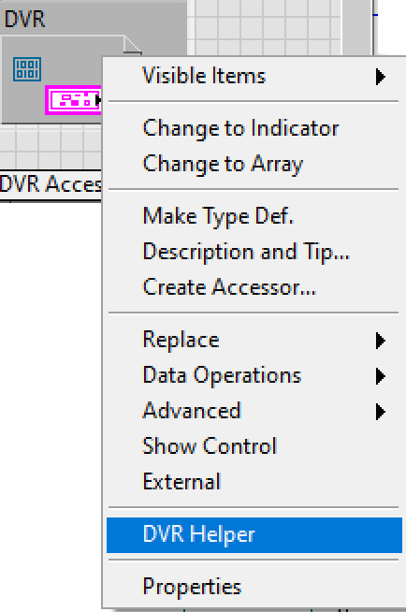

Tree control with all the data members will appear.

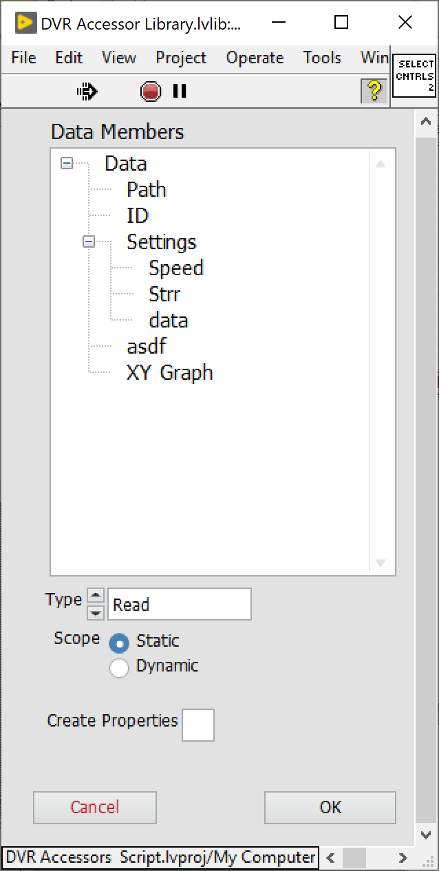

Options:

1. Read / Write or both types of accessors
2. Static or Dynamic scope of the VI
3. Either create or not property definition folders for accessors

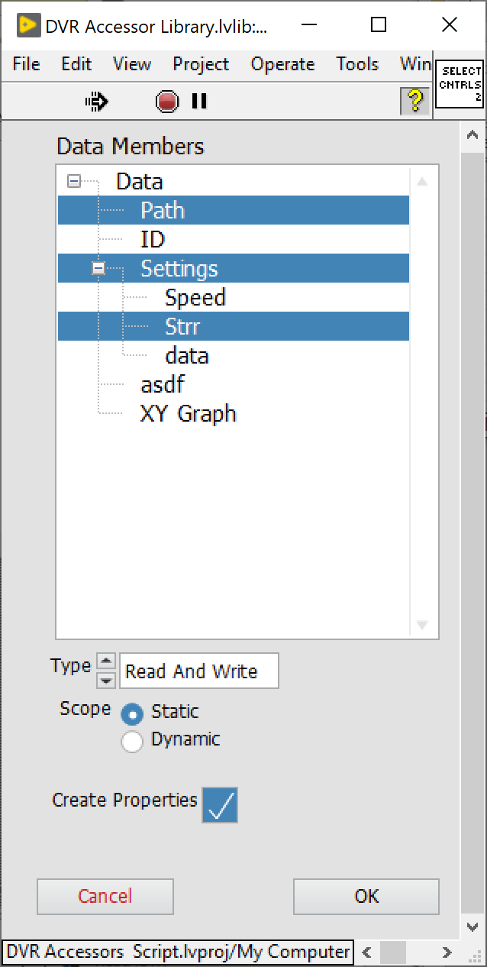

It is possible to select both cluster as a whole and it’s individual elements.

Click ok and wait until accessors are created.

Once generation process is complete new Vis will be placed in the accessors virtual folder

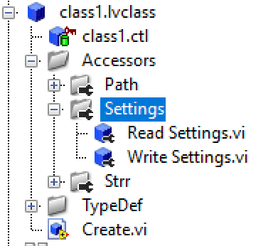

If “Create Properties” was selected accessors will be placed in special property definition folders.

Icons are also automatically generated based on class’s icon, read/write type and name of the accessor.

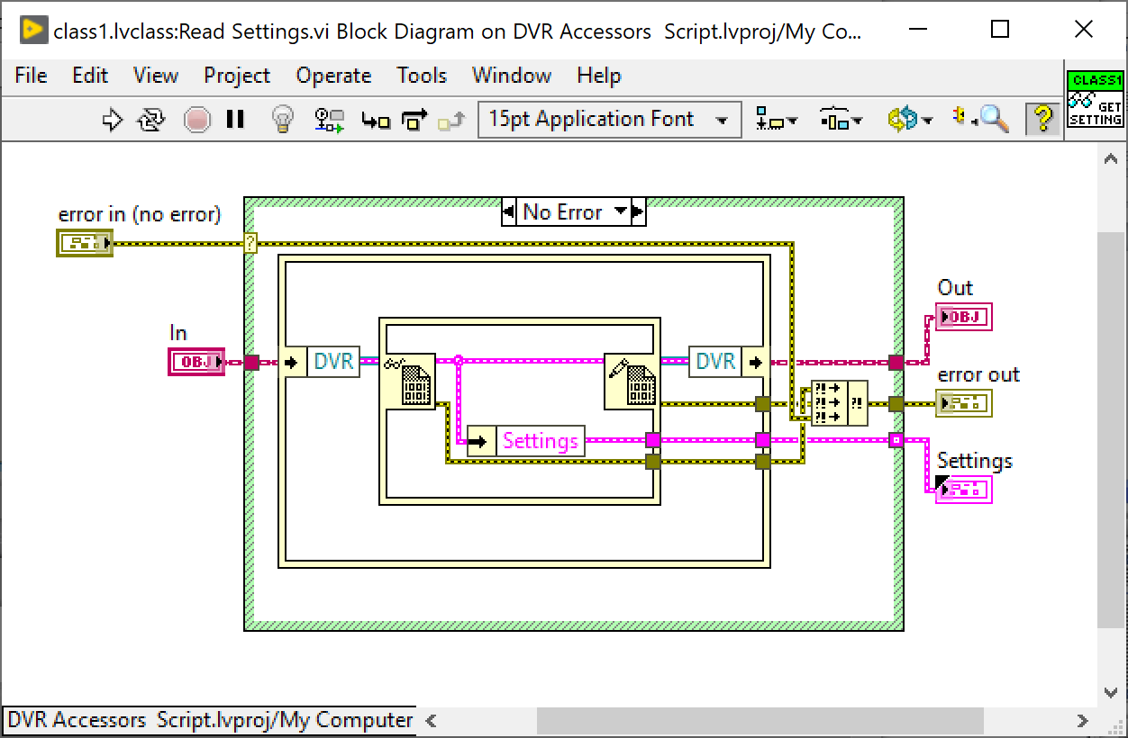

Known issues:

Error happens if there are special characters used in names of data members. – Files with those names cant be created.

If there is a cluster in a cluster in the array then option would be presented to create accessors to the members of that cluster. – Elements of the arrays should not offered as an option. There is a check for the first level of ownership. There should be recursive check instead.